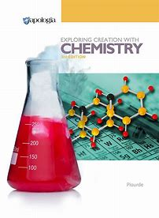
Chemistry
Curriculum text
Apologia Exploring Creation with Chemistry, 3rd Edition, Plourde
Grades 10 - 12
Instructor
Stephanie Lowe, Ph.D. lowesl@bellsouth.net (321) 863-4078 cell
Pre-requisites Algebra I
Requirements
Textbook Apologia Exploring Creation with Chemistry, 3rd Edition (ISBN:978-1-940110-25-7); Solutions and Tests Manual (ISBN: 978-1-940110-26-4), 3 ring binder with 5 divider tabs for Notes, OYO, Study Guides, Lab reports, Tests; notebook paper; pencil; scientific calculator
Class: Tuesdays - 1.5 hours
Tuition: $30/month
Supplies fee: $30/semester

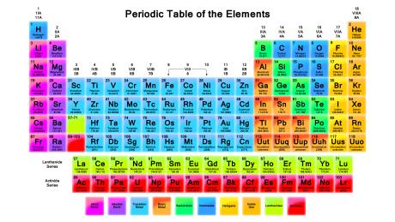

Course overview This course is designed to be a college-prep high school chemistry course. The modules cover significant figures, units, classification, the mole concept, stoichiometry, thermochemistry, thermodynamics, kinetics, acids and bases, redox reactions, solutions, atomic structure, Lewis structures, molecular geometry, the gas laws, and equilibrium.
The curriculum is composed of sixteen modules. Each will be covered over 2 weeks.
Instructor responsibility C0-op class time will consist of lectures to explain and discuss topics and the performance of all experiments from the text (some experiments may be adapted to a classroom setting or substituted out with other appropriate experiments at instructor’s discretion).
The instructor will grade the student’s homework (Complete/Incomplete), laboratory reports (Complete/Incomplete), and module tests (Percent Correct). The instructor will also administer and grade the mid-term and final exams (Percent correct).
An e-mail will be sent weekly to notify parents of grades and missing assignments.
Student responsibility Students are expected to complete daily reading assignments, answer “On Your Own” questions, complete the study guide at the end of each module, write laboratory reports, and complete a module test upon completion of each module. All homework is to be turned in at co-op class on Tuesday. Late assignments will be accepted with a written note from the parent.
Grades 65% Tests 25% Laboratory Reports 10% Homework

